**Hall Effect**

Name : Hardik Shah

Roll No. : 16010221025

Branch : ETRX

Batch : D2

**Aim:** To calculate the carrier concentration by fixed hall current and plotting a graph of hall voltage and magnetic field.

**Apparatus:** Two solenoids, Constant current supply, four probe, Digital gauss meter, Hall effect apparatus (which consist of Constant Current Generator (CCG), digital milli voltmeter and Hall probe).

**Diagram:**

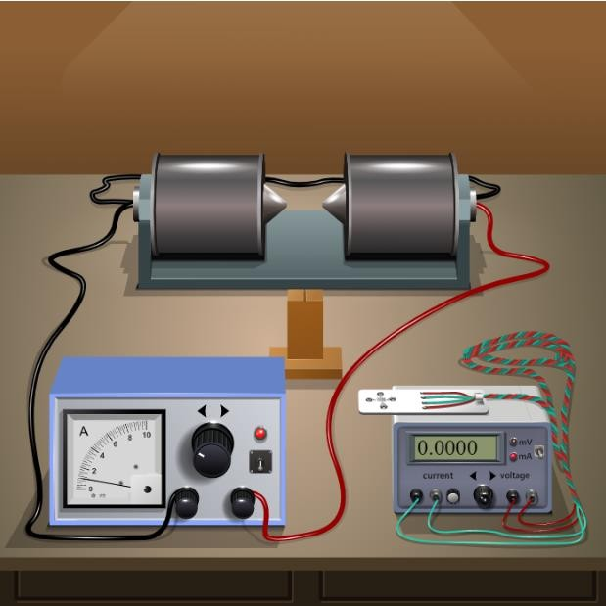

**Observation Table:**

Material: Germanium

Magnetic field B = 0.447 gauss = _44.7 * 10-6_ tesla

|  |  |  |  |
| --- | --- | --- | --- |
| Thickness t = 0.4 mm | | Thickness t = 0.8 mm | |
| IH mA | VH mV | IH mA | VH mV |
| 1 | 0.1482 | 1 | 21.567 |
| 1.5 | 0.2223 | 1.5 | 32.350 |
| 2 | 0.2964 | 2 | 43.133 |
| 2.5 | 0.3706 | 2.5 | 53.917 |
| 4 | 0.4447 | 4 | 64.700 |
| 3.5 | 0.5188 | 3.5 | 75.484 |
| 4 | 0.5929 | 4 | 86.267 |
| 4.5 | 0.6670 | 4.5 | 97.050 |
| 5 | 0.7411 | 5 | 107.834 |

**Graph:**

Plot Hall voltage (Y-axis) v/s Hall current (X-axis) for different thicknesses

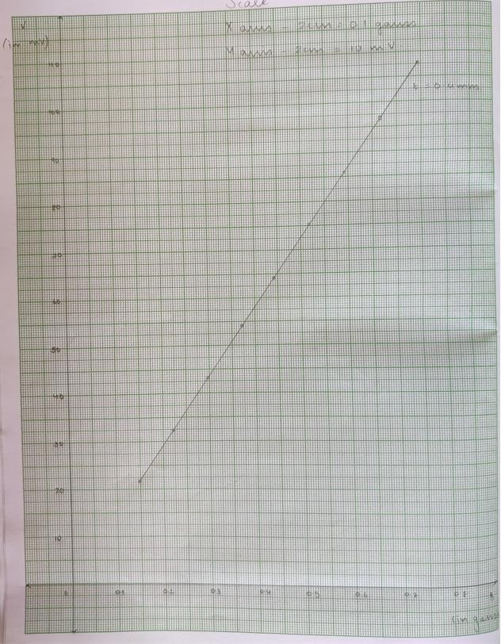

**Formula:** carrier concentration

**Calculations:**

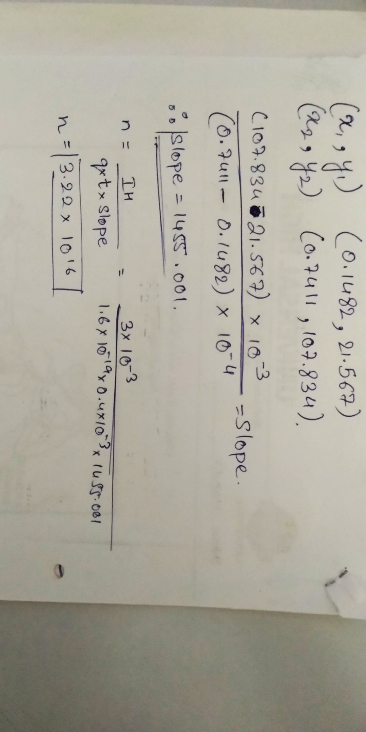

**Home Assignment:**

Keep Hall current (IH) fixed at 3 mA. Vary Magnet current in steps of 0.5 A and note Hall voltage. Plot graph of Hall voltage (Y-axis) v/s Magnetic field* for any one thickness. Calculate carrier concentration using the formula:

*Find magnetic field for different magnet currents by selecting “Magnetic field v/s Current” from the “Select Procedure” drop-down menu of the simulator.

Observation table for Home Assignment:

Material: Germanium

Hall current: 3 mA

|  |  |  |
| --- | --- | --- |
| Thickness t = 0.4 OR 0.8 mm | | |
| I ampere  (magnet current) | B gauss | VH mV |
| 1 | 0.1482 | 21.567 |
| 1.5 | 0.2223 | 32.350 |
| 2 | 0.2964 | 43.133 |
| 2.5 | 0.3706 | 53.917 |
| 4 | 0.4447 | 64.700 |
| 3.5 | 0.5188 | 75.484 |
| 4 | 0.5929 | 86.267 |
| 4.5 | 0.6670 | 97.050 |
| 5 | 0.7411 | 107.834 |